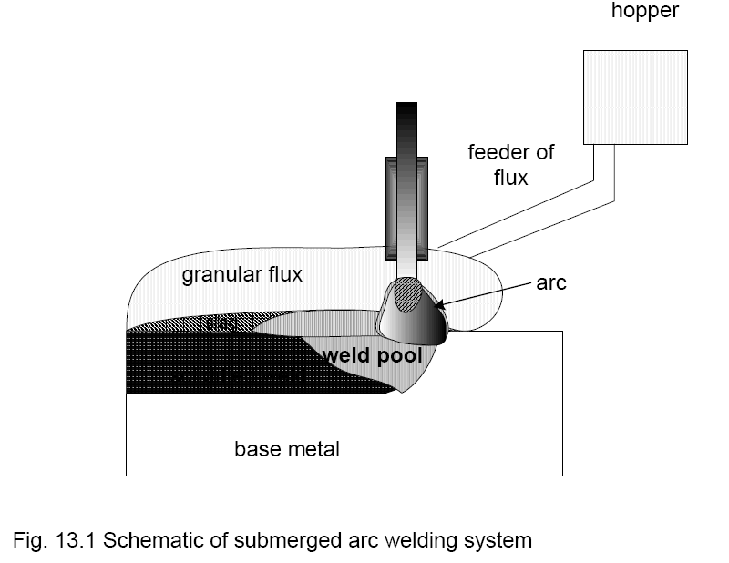
Submerged Arc Welding
This chapter presents the principle of submerged arc welding process besides methods of manufacturing and characteristics of different types of fluxes used in this process. Role of important welding parameters of SAW has also been discussed. Further, the advantages and limitations of this process have been described.
13.1 Introduction
Submerged arc welding (SAW) process uses heat generated by an electric arc established between a bare consumable electrode wire and the work piece. Since in this process, welding arc and the weld pool are completely submerged under cover of granular fusible and molten flux therefore it is called so. During welding, granular flux is melted using heat generated by arc and forms cover of molten flux layer which in turn avoids spatter tendency and prevents accessibility of atmospheric gases to the arc zone and the weld pool. The molten flux reacts with the impurities in the molten weld metal to form slag which floats over the surface of the weld metal. Layer of slag over the molten weld metal results:
■ Increased protection of weld metal from atmospheric gas contamination and so improved properties of weld joint
■ Reduced cooling rate of weld metal and HAZ owing to shielding of the weld pool by molten flux and solidified slag in turn leads to a) smoother weld bead and b) reduced the cracking tendency of hardenable steel
13.2 Components of SAW System
SAW is known to be a high current (sometimes even greater 1000A) welding process that is mostly used for joining of heavy sections and thick plates as it offers deep penetration with high deposition rate and so high welding speed. High welding current can be applied in this process owing to three reason a) absence of spatter, b) reduced possibility of air entrainment in arc zone as molten flux and slag form shield the weld metal a.d c) large diameter electrode. Continuous feeding of granular flux around the weld arc from flux hopper provides shielding to the weld pool from atmospheric gases and control of weld metal composition through presence of alloying element in flux. Complete cover of the molten flux around electrode tip and the welding pool during the actual welding operation produces weld joint without spatter and smoke. In following sections, important components of SAW system and their role have been presented.

13.7 Advantage
Due to unique features like welding arc submerged under flux and use of high welding current associated with submerged arc welding processes compared with other welding process, it offers following important advantages:
➢ High productivity due to high deposition rate of the welding metal and capability weld continuously without interruptions as electrode is fed from spool, and the process works under 100% duty cycle.
➢ High depth of penetration allows welding of thick sections
➢ Smooth weld bead is produced without stresses raisers as SAW is carried out without sparks, smoke and spatter

13.8 Limitations
There are three main limitations of SAW a) invisibility of welding arc during welding, b) difficulty in maintaining mound of the flux cover around the arc in odd positions of welding and cylindrical components of small diameter and c) increased tendency of melt through when welding thin sheet. Invisibility of welding arc submerged under un-melted and melted flux cover in SAW makes it difficult to ensure the location where weld metal is being deposited during welding. Therefore, it becomes mandatory to use an automatic device (like welding tractors) for accurate and guided movement of the welding arc in line with weld groove so that weld metal is deposited correctly along weld line only.
SAW produces coarse grain structure due to high heat input. Coarse grain structure in deteriorate the mechanical properties of the weld joint specifically toughness. Therefore, SAW weld joints are sometime normalized to refine the grain structure and enhanced the mechanical properties so as to reduce the adverse effect of high input of SAW process on mechanical properties of the weld joints.

